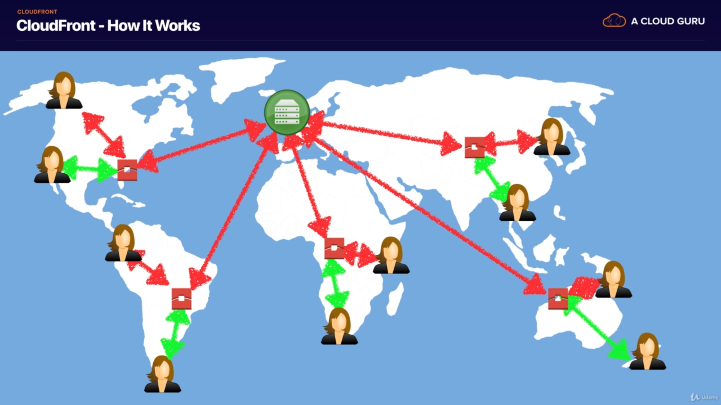

If user requests a video, it’ll be cached in the Edge Location. Later if any other user requests the same content, it’ll be served from the nearest Edge Location.